**What is Spring boot? and What problem does Spring Boot Solves?**

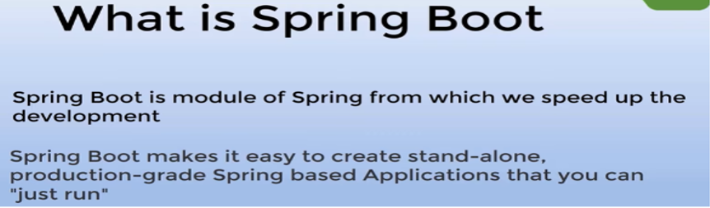

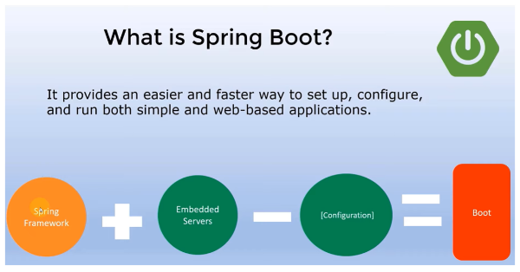

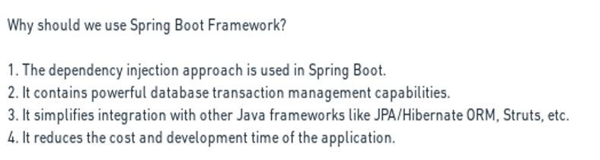

**Explain a few important Spring Boot Key features?**

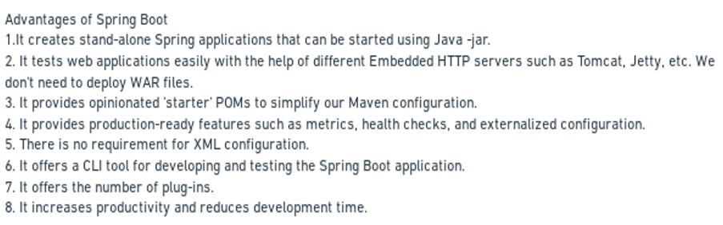

**What is Spring Boot Auto Configuration?**

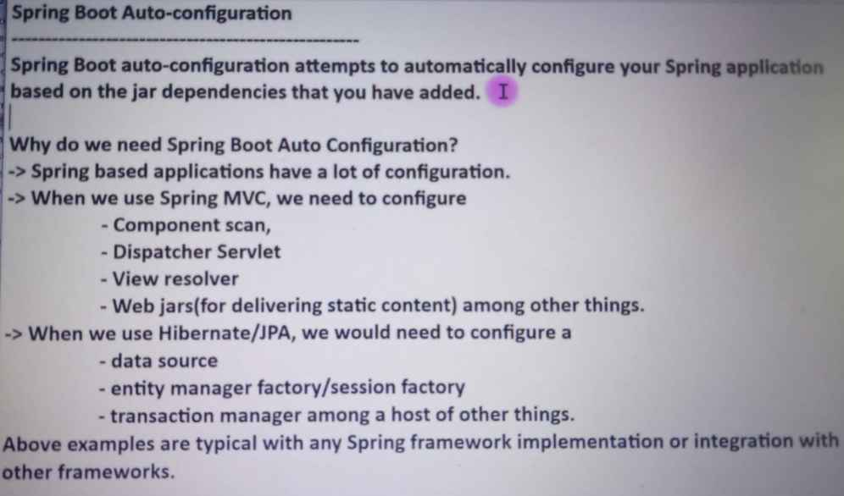

**How Spring boot internally works or Explain the run() method in Spring boot?**

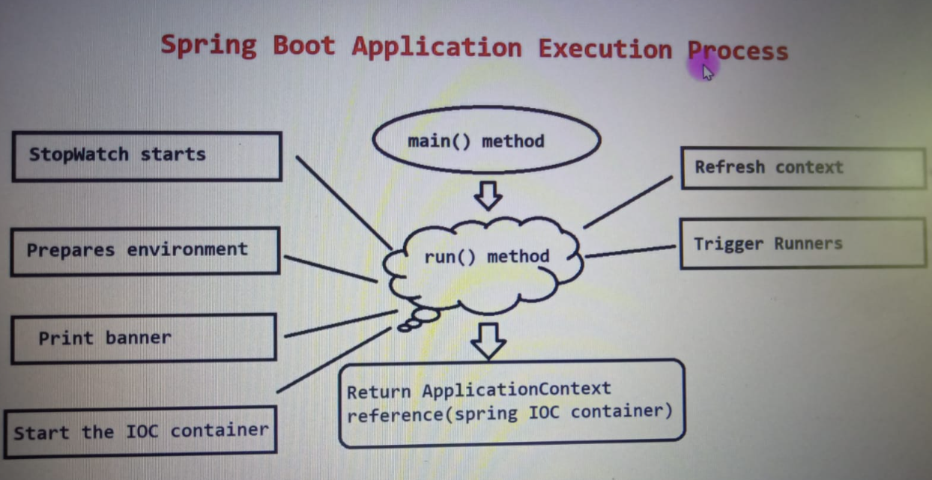

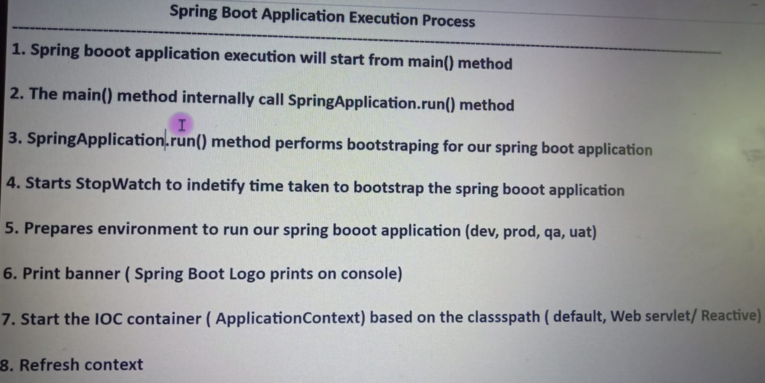

**What are different ways to create a Spring boot application?**

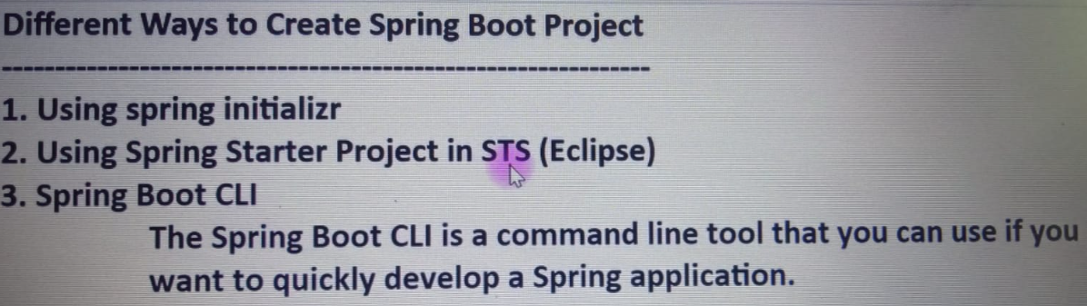

**Explain @SpringBootApplication,@Configuration, and @ComponentScan annotations**

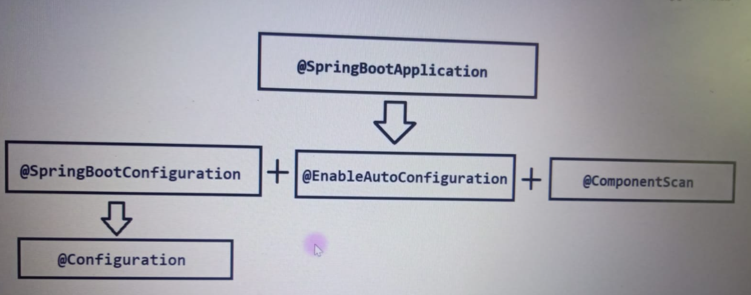

@Configuration = java-based configuration

@SpringBootConfiguration = Spring boot level Configuration

@EnableAutoConfiguration = It enables auto configurations like dispatcher servlet ..

@ComponentScan = It use to scan your base packages along with sub packages which has beans or component.

**What is Spring boot starters and name a few important Spring boot starter dependencies?**

Spring MVC problem: We have to add more dependency and maintain version of each spring

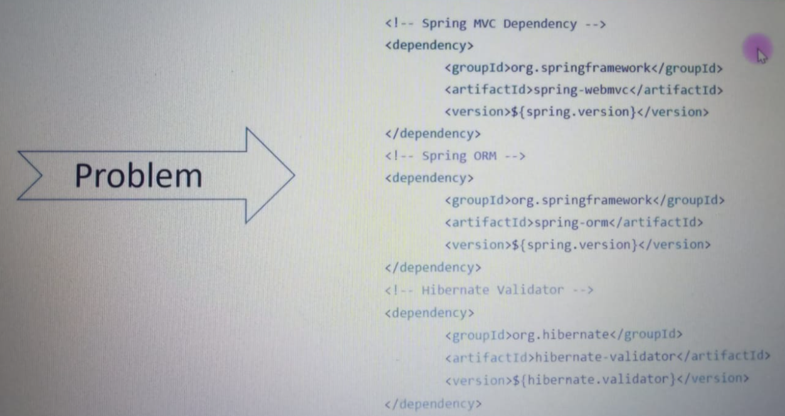

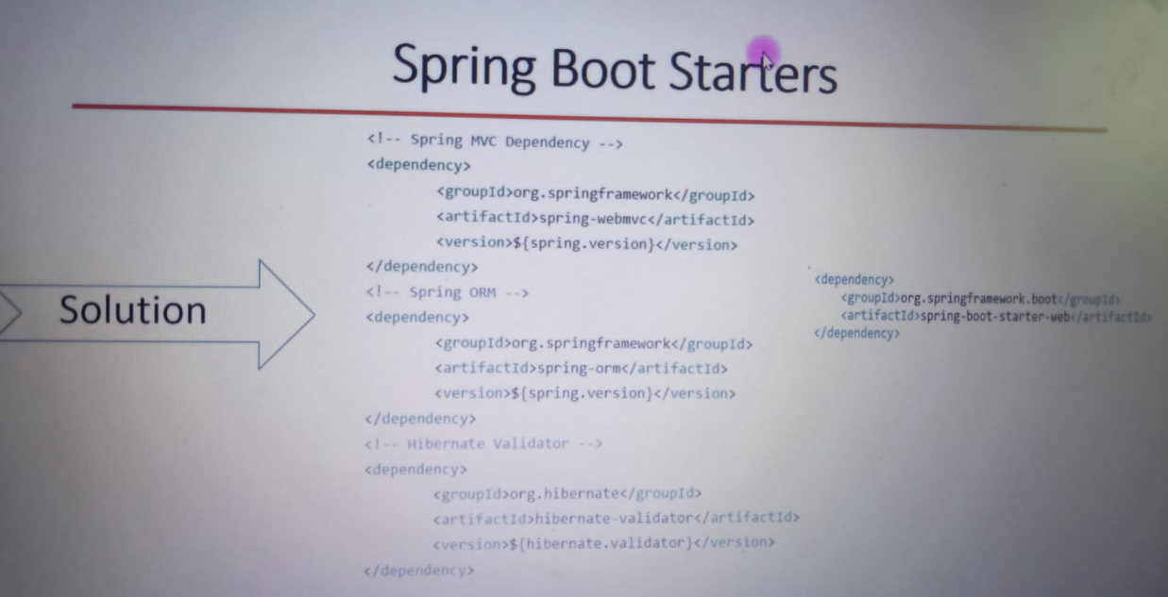

We can only one dependency instead of all this so we have started dependency to resolved it.

**What is Spring Boot Starter Parent?**

In this Starter Parent you can java version, maven plugins and versions and properties.

Your started parent version is given to all started dependencies.

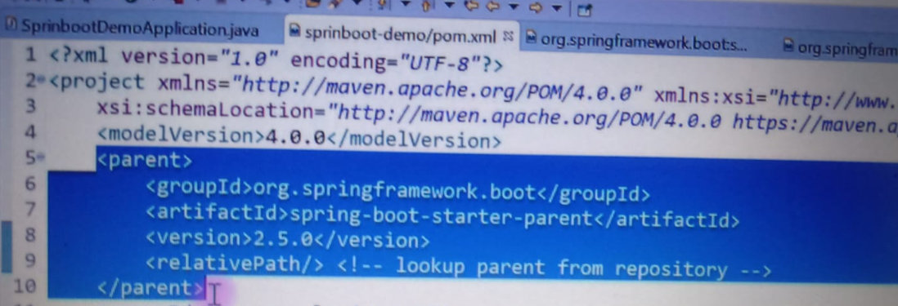

**How many types of projects we can create using Spring boot?**

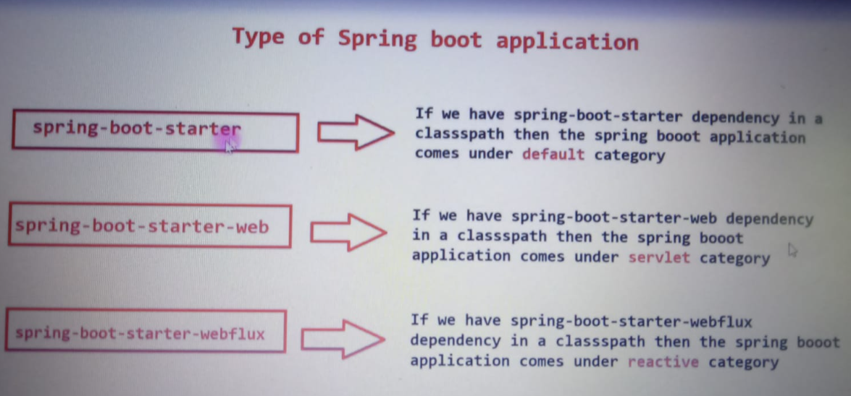

1. Spring boot starter – used for GUI Based or desktop
2. Spring Boot starter-web – web application and rest API
3. Spring-boot-starter-webflux – make reactive web application

**Explain types of Embedded Servers in Spring boot? How to change the default server port?**

default : Tomcat and support : Tomcat, Jetty,undertow

Change port number = server.port = 8081

If you want to change server from tomcat default to any else

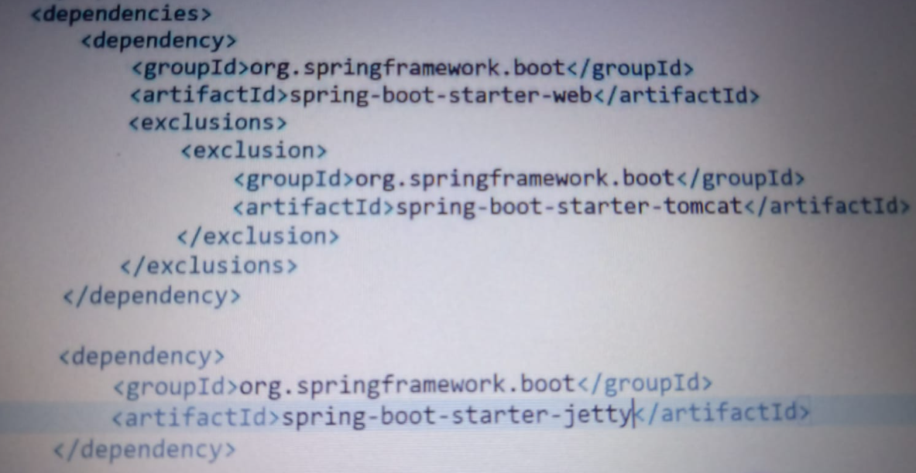

**How to run Spring boot application from the command line?**

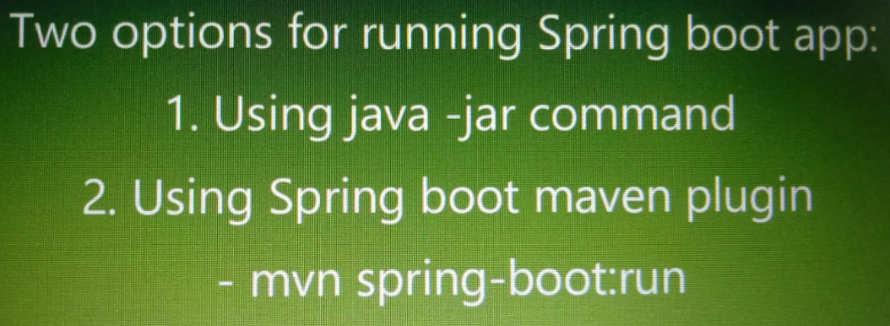

If maven installed then use mvn

If not then use mvnw

You should be inside your folder

first way: mvnw package , dir, cd target, u find your jar , java -jar your_jar_name

second way: mvnw springboot:run

**Describe the flow of REST API HTTP requests through the Spring Boot application?**

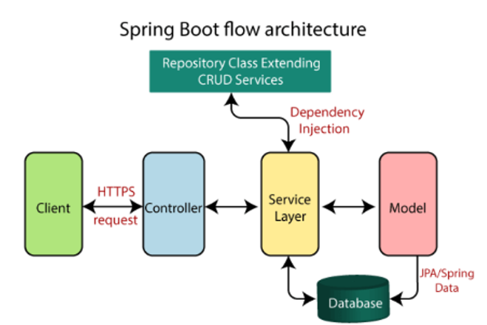

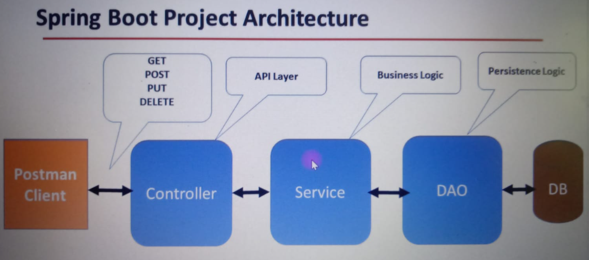

**How to create and deploy Spring boot WAR to External Tomcat Server**

* Change package form jar to war
* Paste your created war file in apache tomcat folder in webapps
* 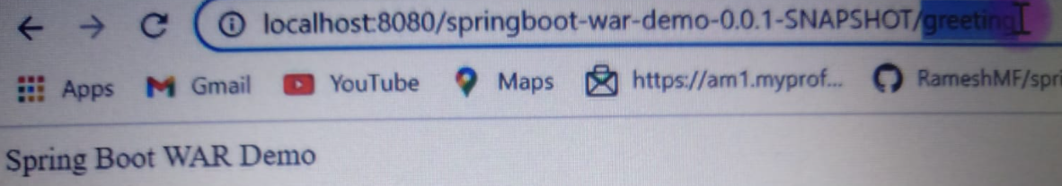

**What Is Spring Boot DevTools Used For?**

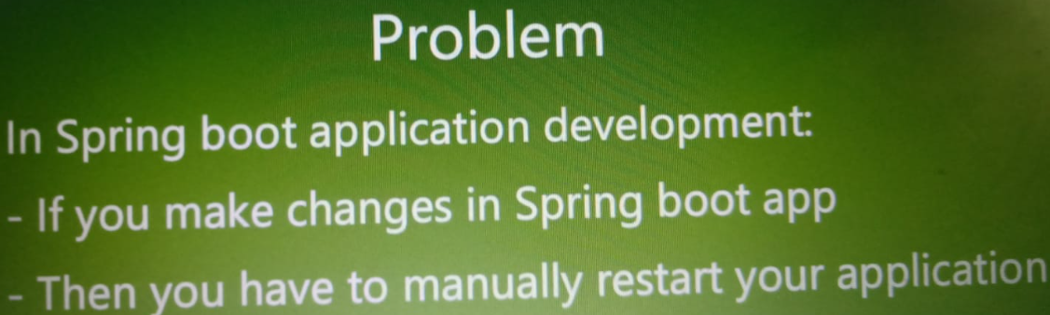

**How to Add Security to Spring Boot and Explain Security Auto Configuration?**

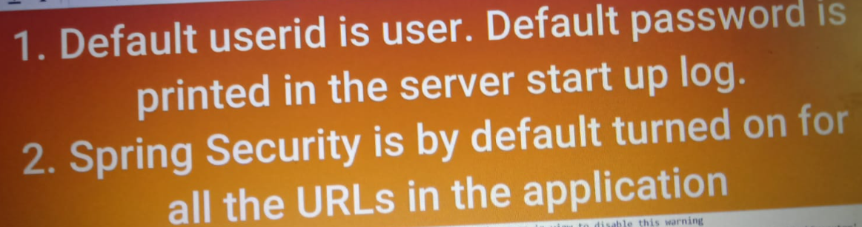

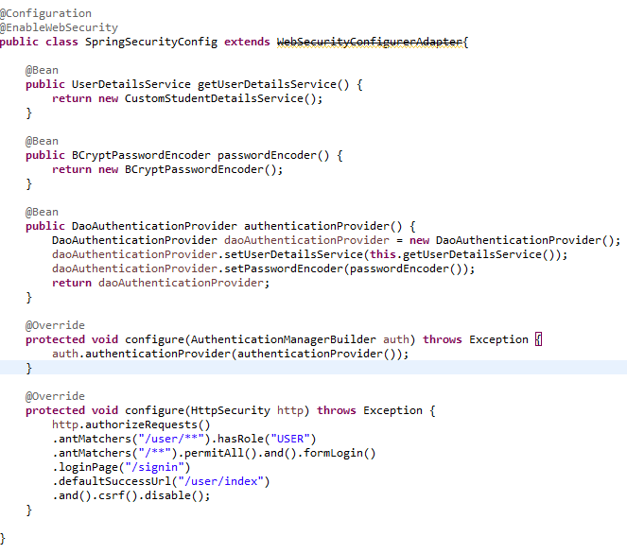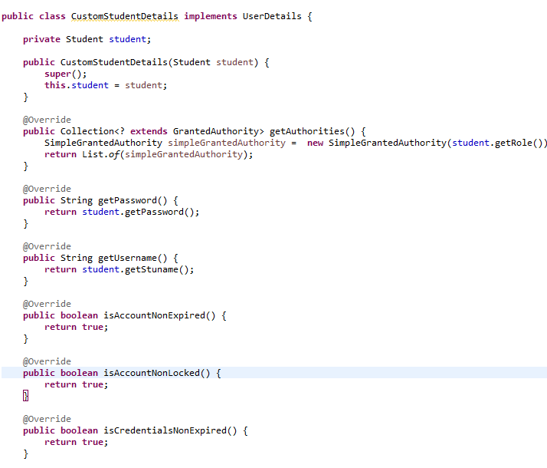

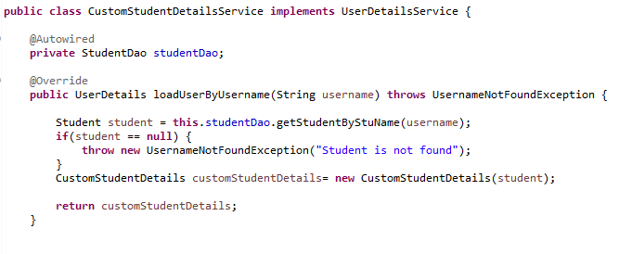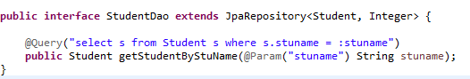

**Have you used profiles in your Spring Boot project? If yes, Explain briefly?**

* It is used to set different profile for your app like dev and test and prod or qa
* You need to create more than application-env_name properties file for different env and in main application.properties you need to active profile
* Spring.profiles.active = prod

**Can We exclude auto configuration ?**

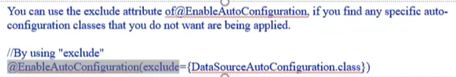

**How can you use your property from application file to your business logic?**

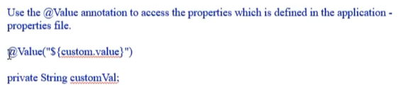

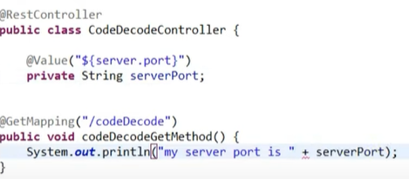

**What are Differences of @Controller and @RestController ?**

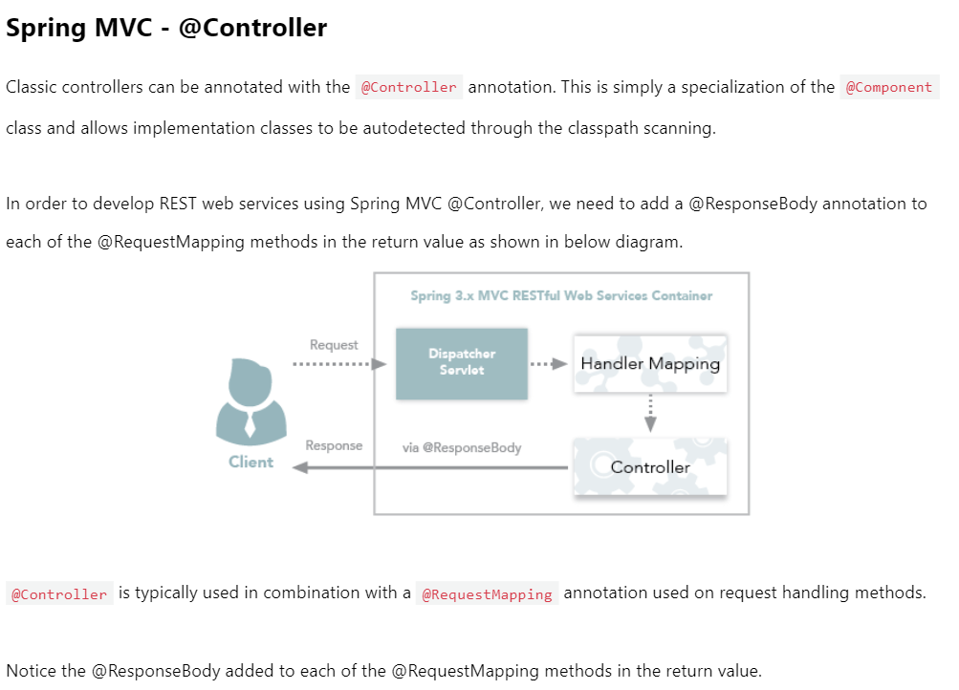

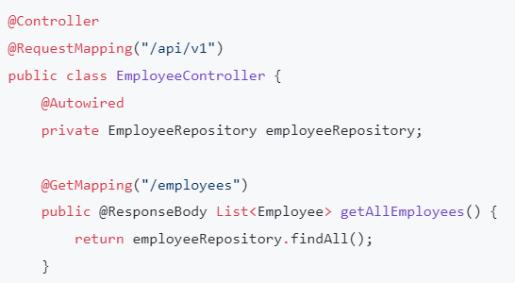

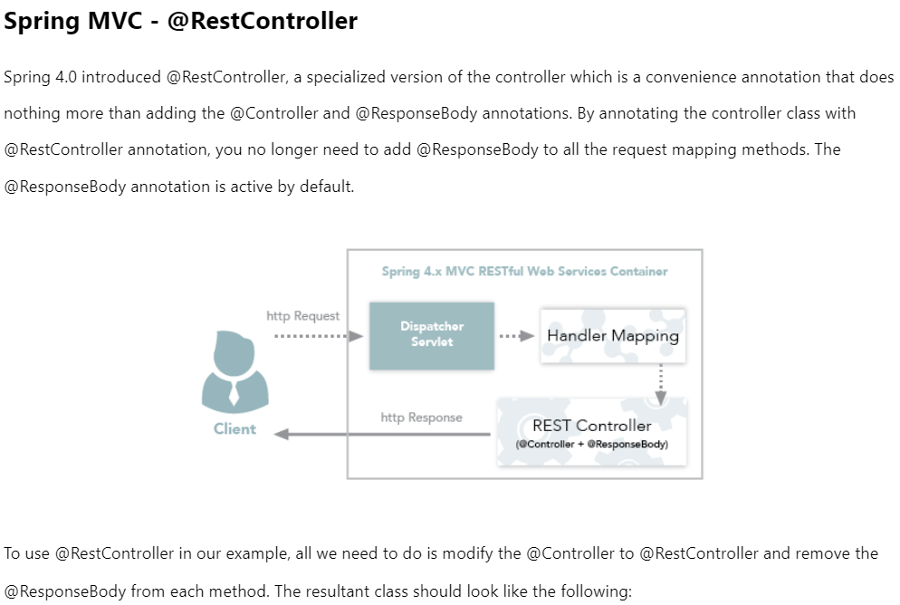

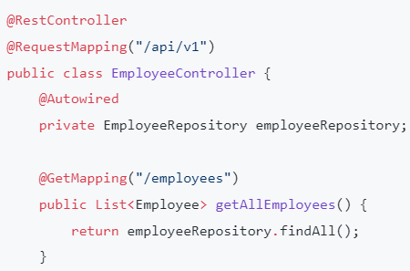

**What are the differences of @RequestMapping and @GetMapping?**

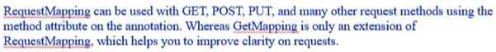

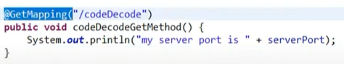

**What is REST?**

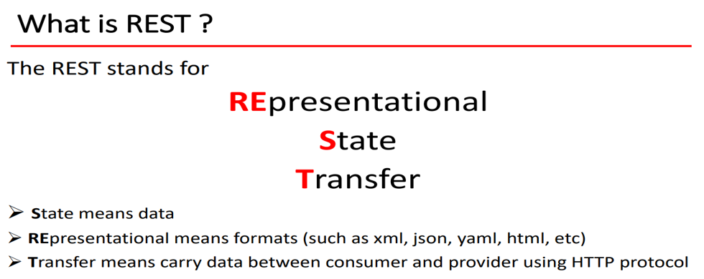

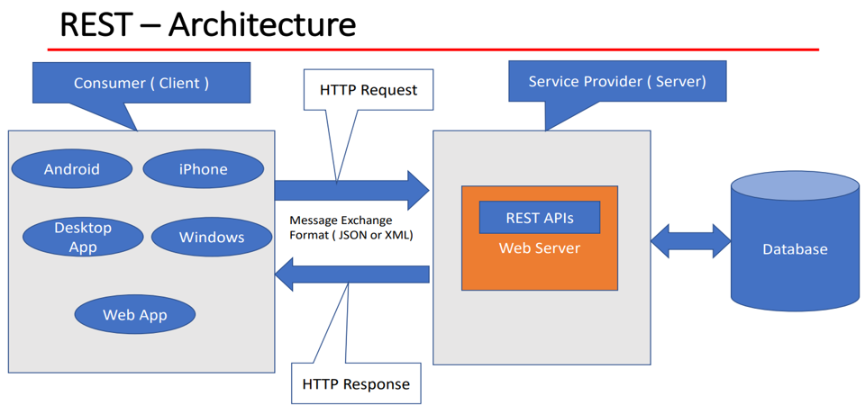

**What are the key concepts in REST API?**

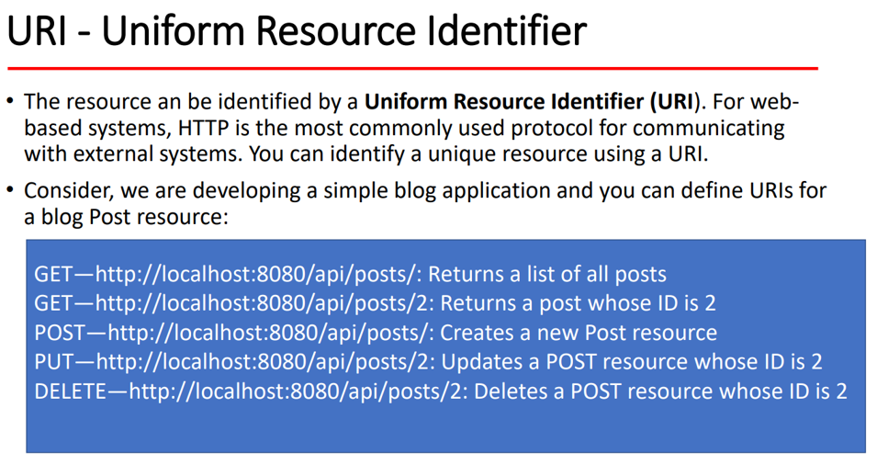 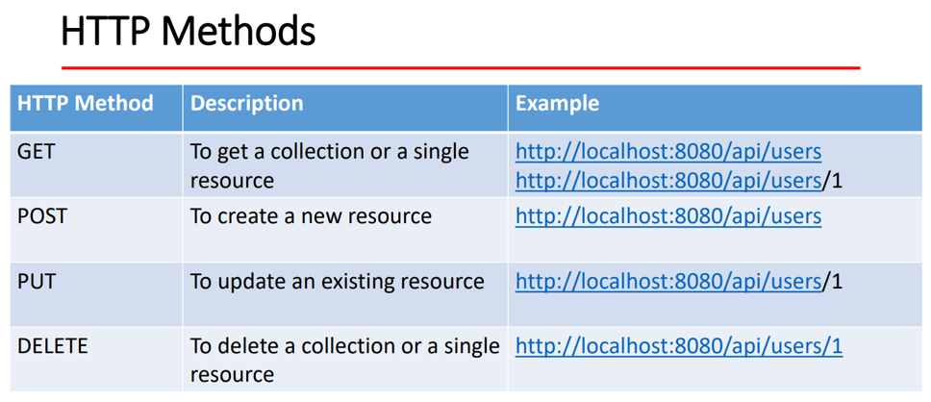

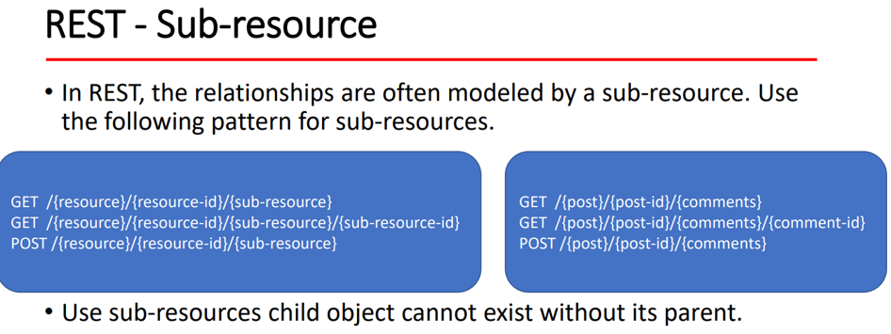

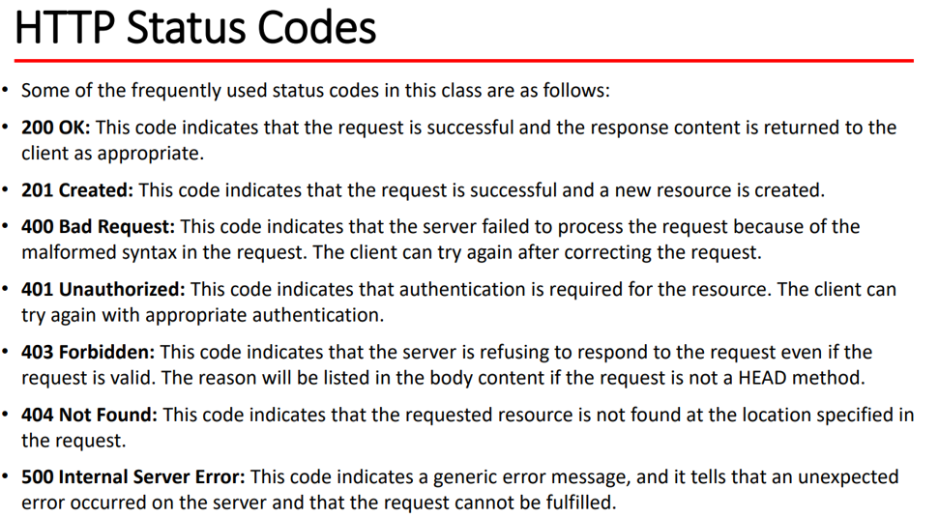 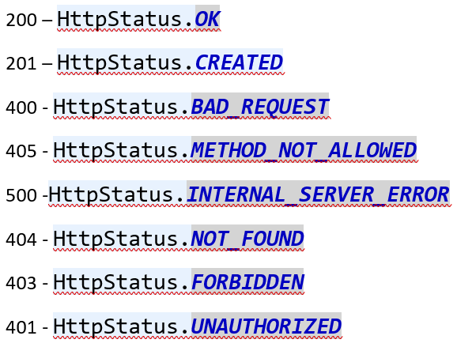

**What is architecture of Spring Boot?**

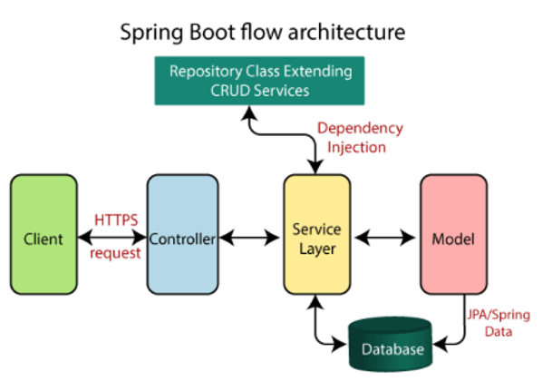

**What are differences of crud repository & JPA repository?**

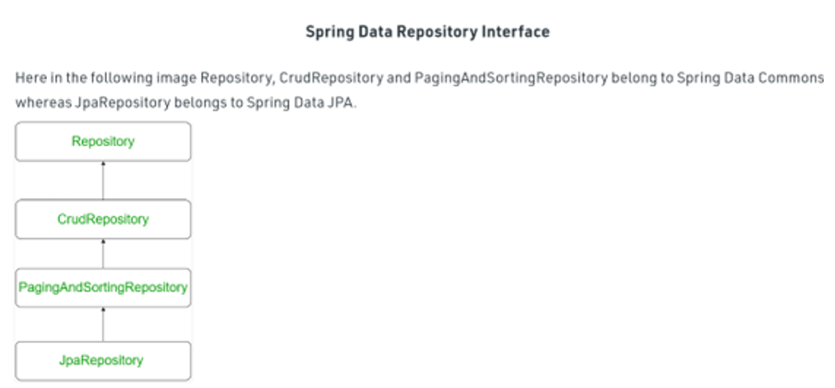

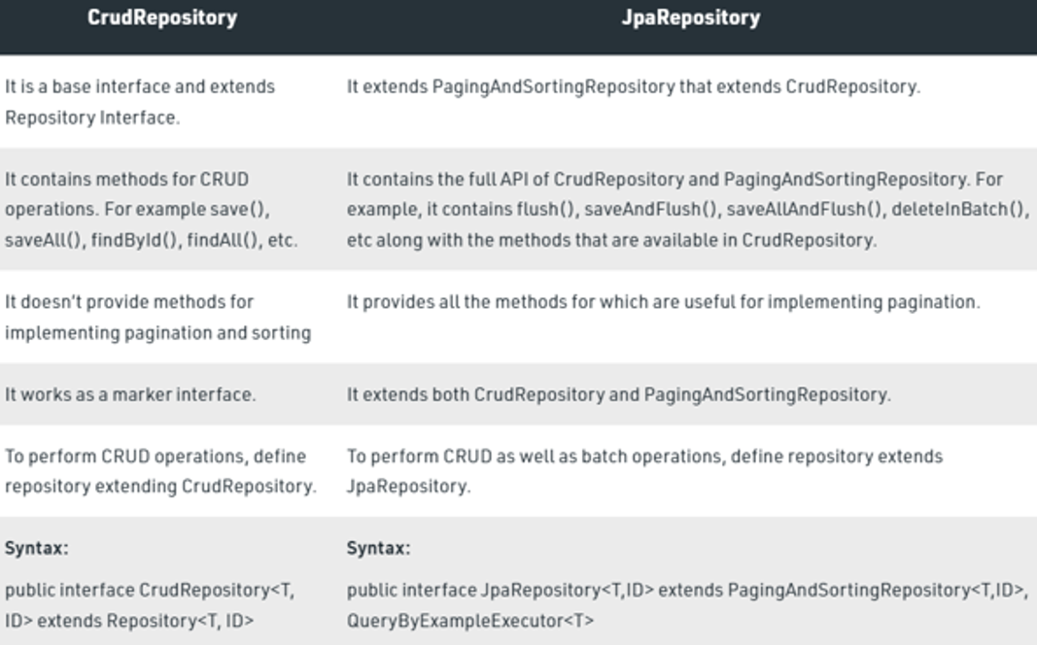

**Do we need add @Repository on CRUD repository & JPA repository interface?**

* **No**
* 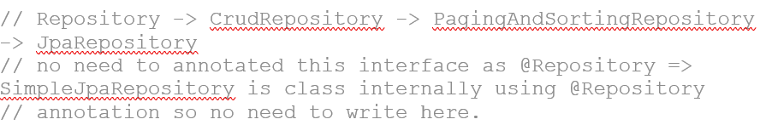

**How to create Custom Exception in spring boot?**

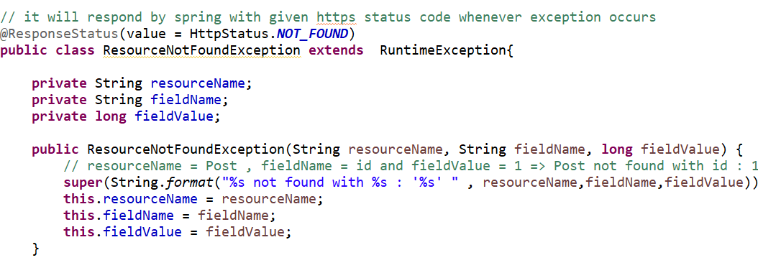

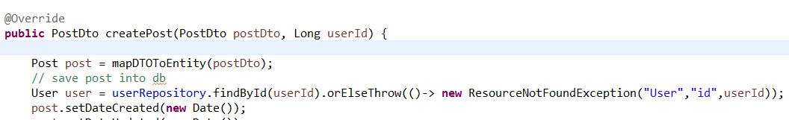

**What design pattern followed by spring boot to make REST-API?**

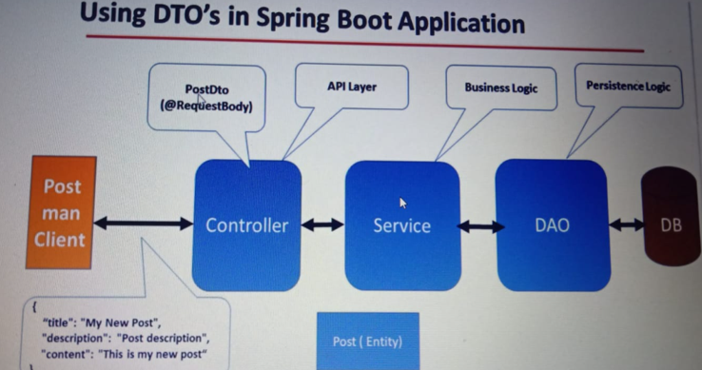

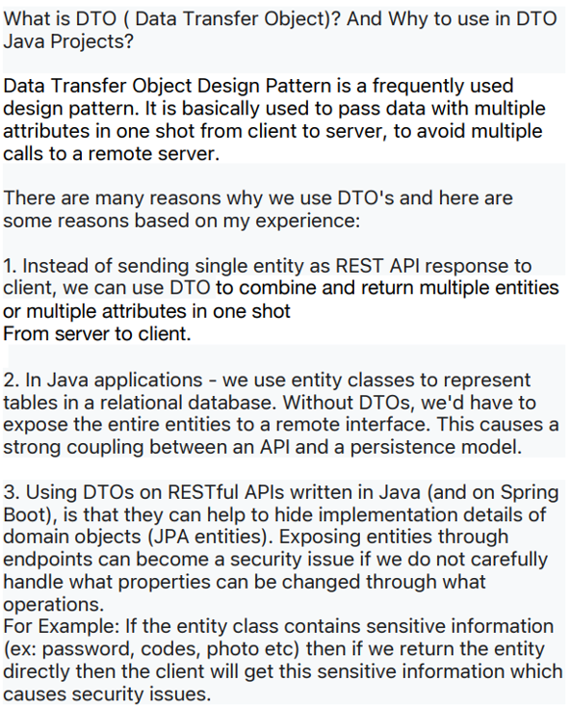

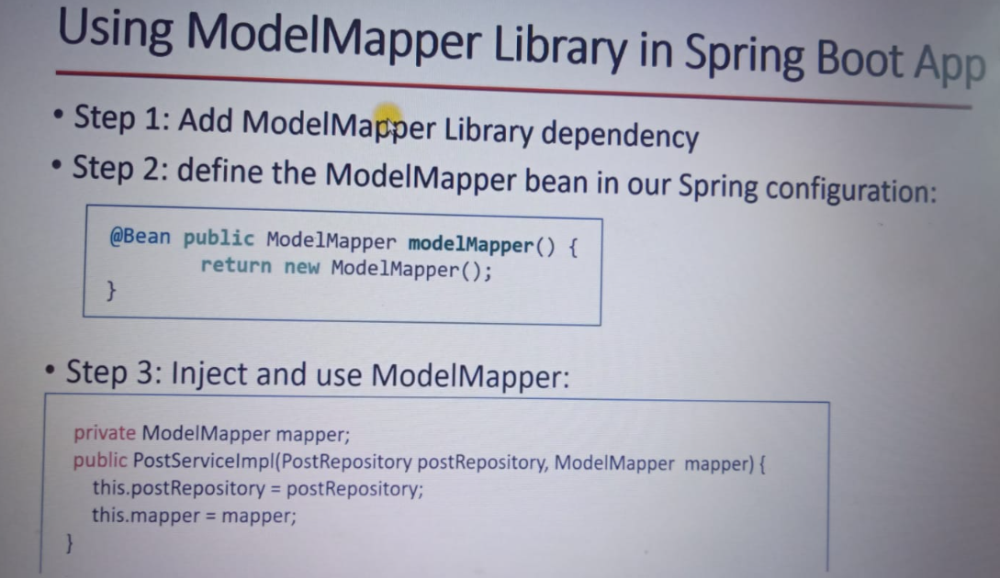

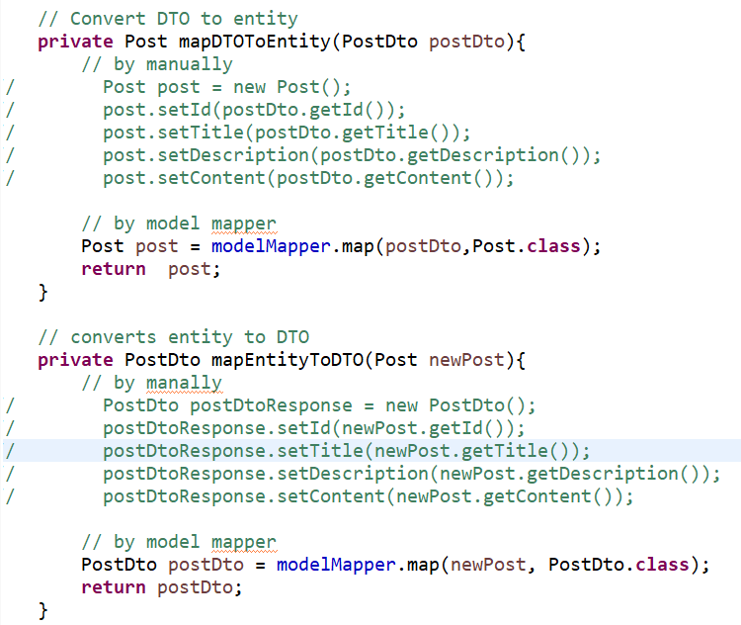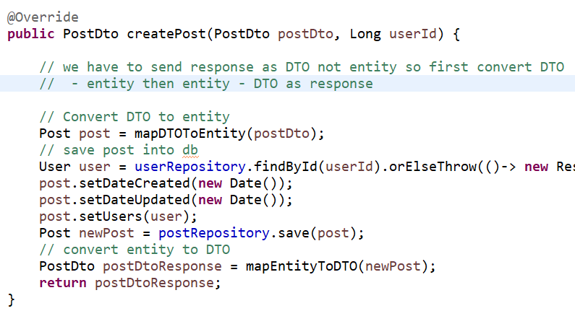

**How to implement pagination and sorting in spring boot?**

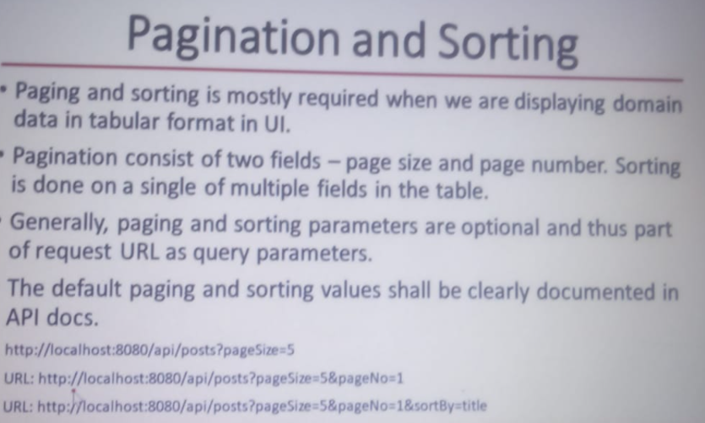

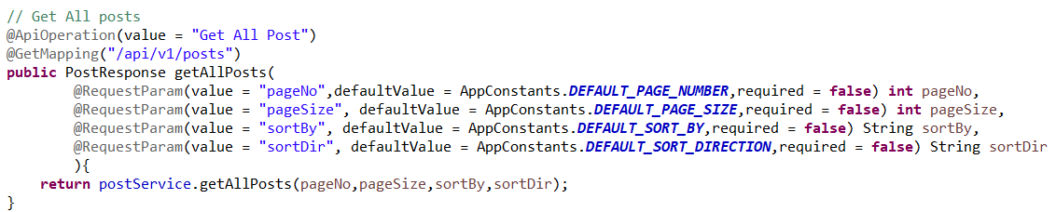

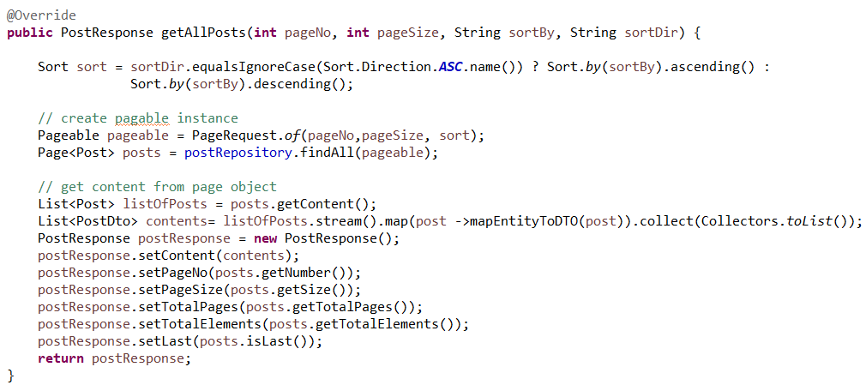

**What is JWT?**

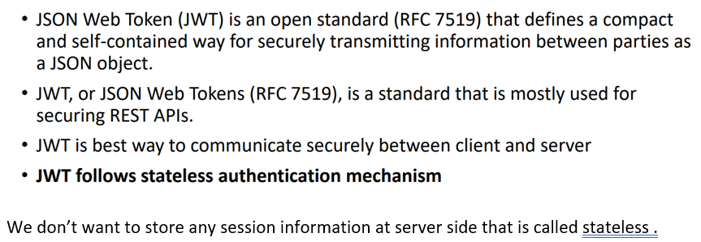

**What are structure of JWT token?**

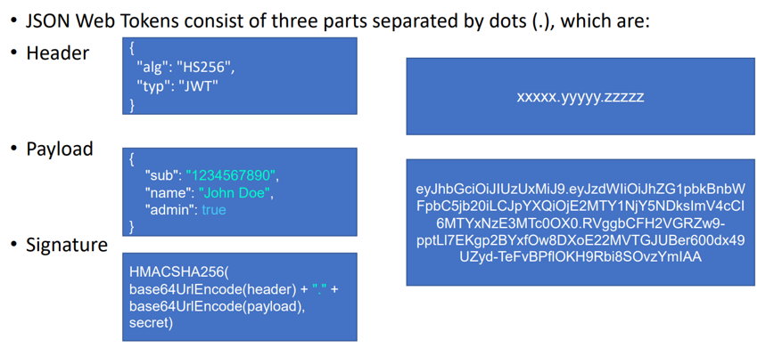

**How JWT works?**

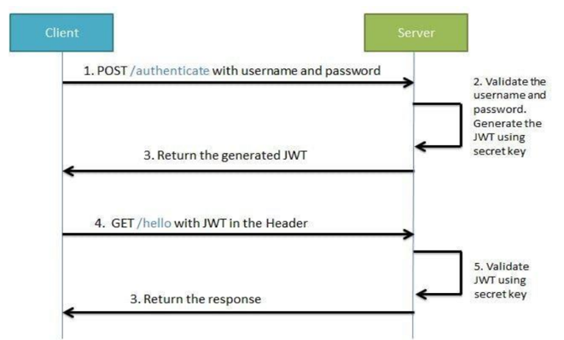

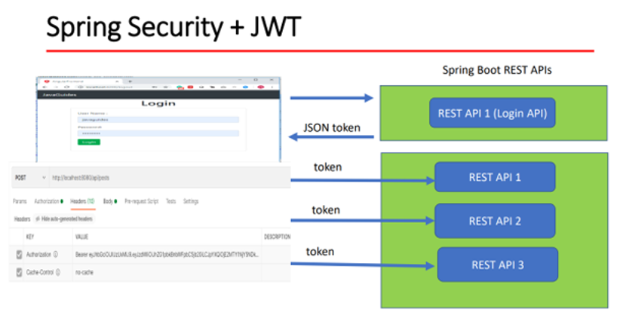

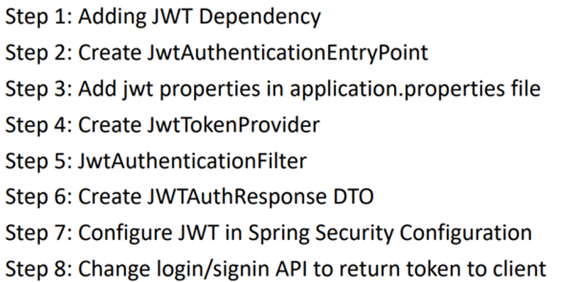

<dependency>

<groupId>io.jsonwebtoken</groupId>

<artifactId>jjwt</artifactId>

<version>0.9.1</version>

</dependency>

**How to do versioning of API?**

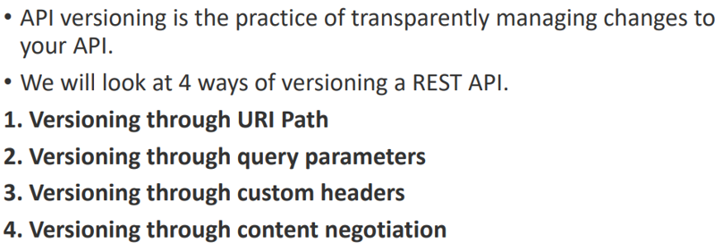

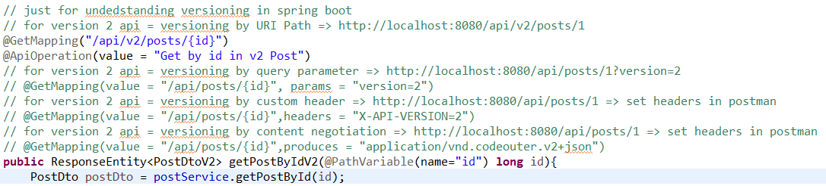

**When and why we need versioning of API?**

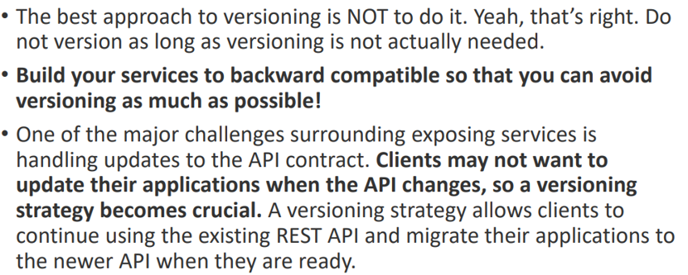

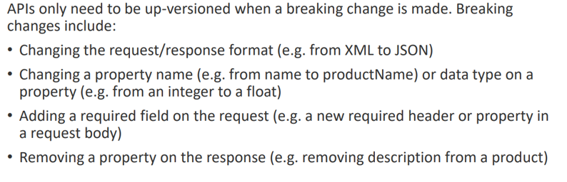

**How to document REST-API?**

* **Swagger 3**

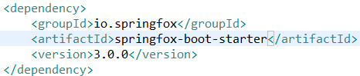

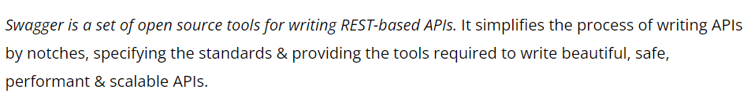

**What are differences of OPEN-API and Swagger?**

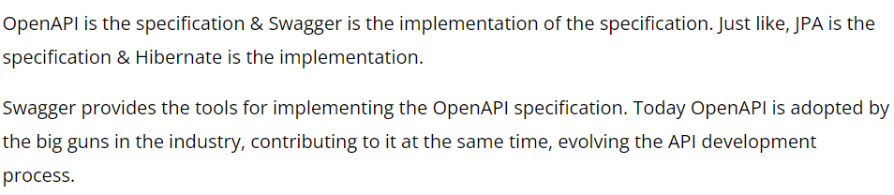

**What are annotation in swagger?**

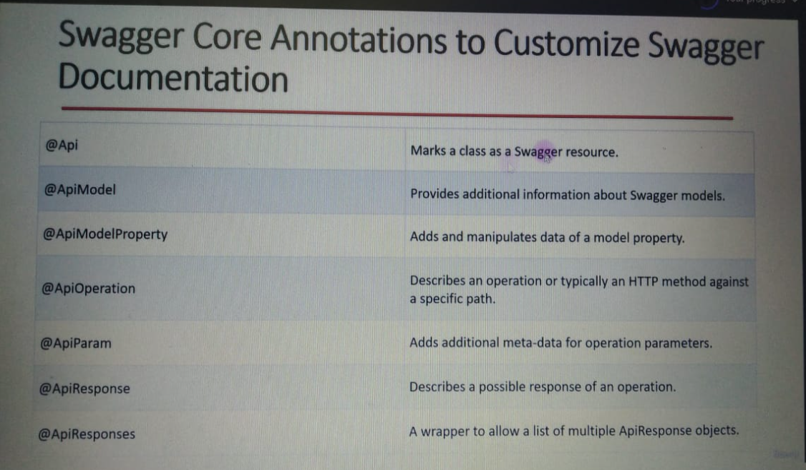

**What are differences of REST & SOAP?**

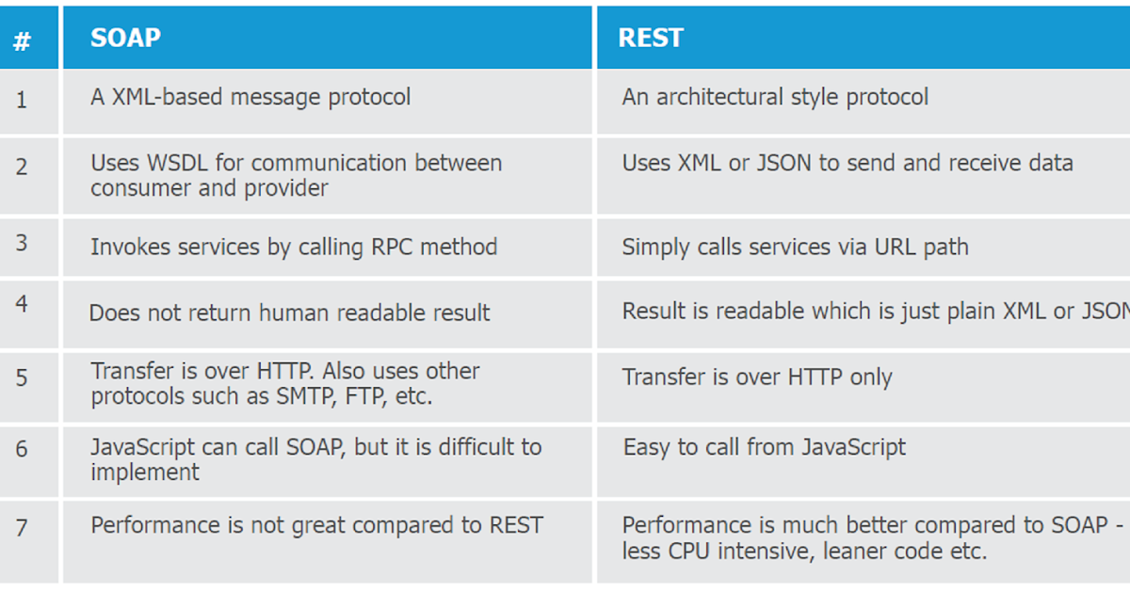 **What are differences of REST & RESTFUL API?**

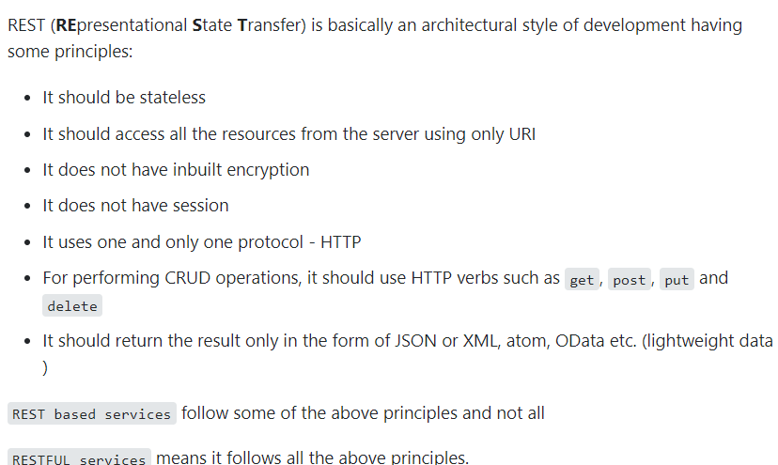

**What is SOUP-UI?**

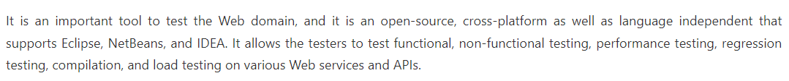

**What is SOAP & need?**

